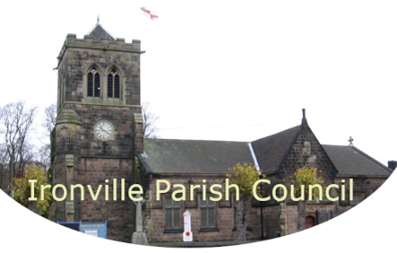
Council Subscriptions
Dalc Membership and Training Package - £449.07
Scribe – financial software - £345.60
NetWise – Website/Emails - £396
Friends of Cromford Canal - £18
Adobe - £50. Cost shared between 4 parish councils

